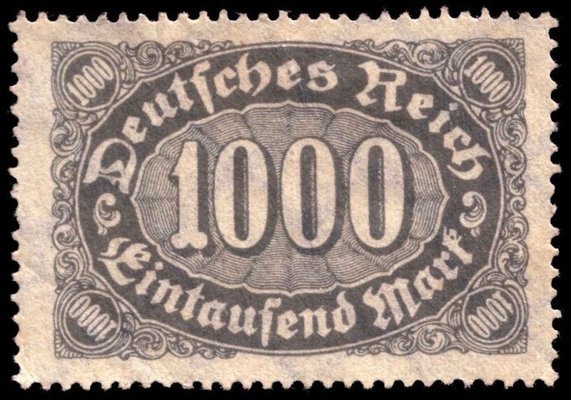

Hyperinflation in the Weimar Republic

Lesson Plan: Hyperinflation in the Weimar Republic
National Curriculum Standards:
- Learners will understand the causes and effects of inflation.
- Learners will be able to explain how monetary decisions at the national level affect households, businesses and governments.
- Learners will be able to analyze and evaluate conditions, actions, and motivations that contribute to conflict and cooperation among groups and nations.
Specific Objectives:
- To identify the reasons for hyperinflation in the Weimar Republic
- To understand how the Treaty of Versailles placed an unrealistic debt in Germany which would eventually lead to the rise of Hitler and World War II.
Materials:
- Fake money. (either bought or printed if your school has a cutter.) Make sure there are enough units of $1 so students are not struggling for change.
- Papers (preferably color)
- Markers
Procedure:
Start by reviewing the Treaty of Versailles and how it unfairly placed the blame and a huge debt burden on Germany. ($33 billion). Then tell the class that the Weimar Republic, which was the democratic government set up in Germany after the war came up with an ingenious solution to pay off the debt.
To realize how this is going to affect Germany, start a game in which the class will simulate the German economy in the 1920’s. You may want to start off by having students clear up some desks to the sides of the classroom. Divide the class into seven or eight groups. There should be about five groups of German merchants and about two or three groups of British and French “tourists” that will visit Germany. Each German merchant group will sell a specific product during five rounds. Some ideas for German products: Bread, Milk, Beer, Brats, chocolates. Of course, they do not need these items in class. Simply prepare ahead these items by drawing them with markers on colorful paper. Prepare five papers for each item. It may look as simple as this:
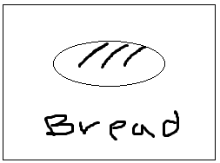
Explain the following rules and goal:
The goal of this game is to end up with as much of a combination of products by the end of all rounds and as much cash. This goal applies to both tourists and merchants. But merchants will compete with merchants and tourists with tourists. (How you reward winners is up to you).
Rules:
- Merchants can set the prices of their products before the round starts. After a round starts, those prices cannot change. (Tell those groups to write clearly the prices using markers and post them at their table so it is clearly visible to all). They also may want to come up with the price quietly without sharing it with other groups.
- Prices have to be in whole numbers. No cents allowed.
- On each round, a merchant group may only sell a product once and also buy a product once. A tourist group may only buy a product once per round.
Once they have understood the rules, give each merchant group $3 to start with. On the first round, tourists will not be involved. Knowing that each has $3, let them set the prices before the round starts and go!
After the first round, announce that you the teacher play the role of the Weimar Republic government and that in order to pay off the German debt, you have “printed” money and decided to give some to the French and the British. Announce that you are giving $5 to each tourist group. Knowing that info, let the merchants set the prices and go!
Second round: Announce that it is not enough. This time you are giving the tourists $10.
Third round: Give tourists $20
Fourth: $30
Fifth: $50

After the activity is over, debrief. Ask them how much their prices went up from the beginning of the activity. Then explain that this is hyperinflation, when the price of products go up significantly. Then give them the following shocking data:
1918- price of bread- < 1 mark.
1922- price of bread- 160 marks
1923- 200 billion marks

Ask them what would have happened if they had been saving for a house around 1918.
Make it a point to show how the Germans were utterly humiliated and that this is why they eventually turned to Hitler. Explain to them that when the situation got so bad, the Americans stepped in to help by loaning Germany money (Dawes Plan). But when the Great Depression hit, Americans couldn’t do it anymore.
Then you may want to continue the lecture/ lesson on the rise of Hitler and how he gained political power.

